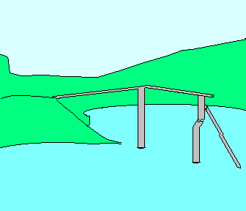
is a dark picture to behold without the Light of Christ shining on it.
Luke 16:24 "...I am tormented in this flame."
is a time all will be fixed and nothing changed. No second chances.
Luke 16:26 “…between us and you there is a great gulf fixed:”
to you are the riches of God almighty.
is a part of this wonderful contract!
one way to be a part of this agreement, and that is by way of the cross.
God can stop that which is driving you and place you in a vehicle called GRACE that will bring you to a life of true fulfillment.

“That if thou shalt confess with thy mouth the Lord Jesus, and shalt believe in thine heart that God hath raised him from the dead, thou shalt be saved.”—Romans 10:9

For more help: Deliverance Center-1008 Congress St. Portland-Maine-04102-Tel: 207-774-8192.

WARNING!!!

The bridge is out

